ADVENTURE WORKS · TECHNICAL SUPPORT

Disc Brakes Squealing or Rubbing
Brakes Document TS-002 Rev. A
Applies to | Trailblazer MTB, Summit Trail, Velocity Road (disc), PowerRide e-Bike
Difficulty | Beginner – Intermediate
Time required | 15 – 30 minutes
Tools needed | 5 mm hex key, Torque wrench, Isopropyl alcohol & clean rag, Rotor truing fork (optional)

Symptoms
- A high-pitched squeal or honk when braking.
- A steady tick or 'shhh' once per wheel revolution while coasting.
- Braking power feels normal but is accompanied by noise.
- Noise is worse in wet conditions or right after washing the bike.
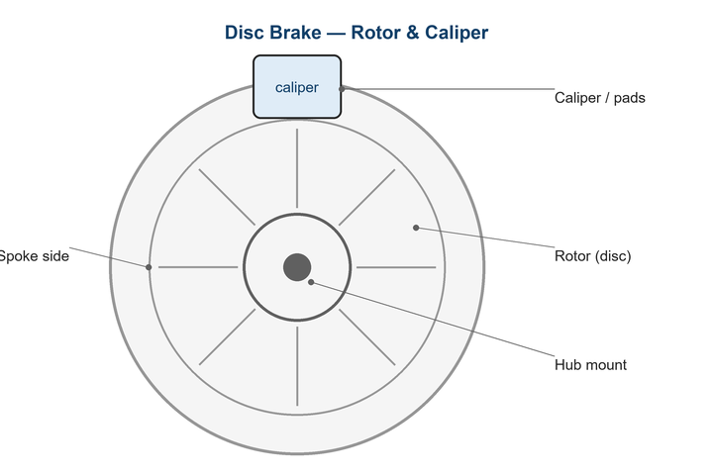
Figure 1. Disc-brake caliper straddles the rotor; pad-to-rotor clearance is only a fraction of a millimetre.

Likely Causes
- Caliper is slightly off-center so a pad lightly drags the rotor.
- Rotor has minor lateral runout (a small bend or warp).
- Pad or rotor contamination from spray lubricant, degreaser, or oily fingers.
- Brand-new pads/rotor not yet bedded in.
- Loose caliper mount or rotor bolts.
Safety first
- A rotor gets very hot during braking — let it cool before touching.
- Never touch the braking surface with bare fingers; skin oil contaminates pads.
- Avoid spray lubricants anywhere near the rotor or caliper.

Customer Fix — Step by Step
Suitable for home repair with basic tools. Work through the steps in order.
- Spin the wheel and look through the caliper slot to see which pad is rubbing the rotor.
- Loosen the two caliper mount bolts about a quarter turn so the caliper can float.
- Squeeze and hold the brake lever firmly; while holding, re-tighten the two mount bolts evenly. This self-centers the caliper.
- Release the lever and spin the wheel — the rub should be gone or greatly reduced.
- If a squeal persists, clean the rotor with isopropyl alcohol and a clean rag, then dry it.
- Bed in the pads: ride at moderate speed and brake firmly 20–30 times to deposit an even pad layer.

Technician Reference
Additional checks and adjustments for service technicians and advanced users.
- Check rotor runout with a truing fork or zip-tie pointer; correct bends >0.2 mm by gently flexing the high spot with a rotor truing tool.
- Confirm rotor bolts (6-bolt) are torqued in a star pattern; check Center-Lock lockring torque.
- Inspect pads for glazing or contamination; deglaze lightly with sandpaper on a flat surface, or replace if oil-soaked.
- Verify the wheel is fully seated in the dropouts and the axle/quick-release is at correct torque — a poorly seated wheel mimics rotor rub.
- For persistent resonant squeal, apply a thin film of disc-brake-rated anti-squeal paste to the back of the pads (never the friction face).

Torque & Specifications
Fastener / setting | Specification
Caliper mount bolts | 6 – 8 N·m
6-bolt rotor bolts | 4 – 6 N·m (star pattern)
Center-Lock lockring | 40 N·m
Max rotor lateral runout | 0.2 mm
Thru-axle | 12 – 15 N·m

Figure 2. Re-center the caliper by holding the lever while tightening the mount bolts.
Pro tips
- Always wash the bike with the rotors pointed away from spray, and keep degreaser well clear.
- Handle rotors by the spider arms, not the braking track.

When to Visit a Service Center
- Rotor runout cannot be corrected or the rotor is cracked.
- Pads are oil-contaminated and squeal returns after replacement.
- Noise is accompanied by a loss of braking power.
- You suspect a seized caliper piston (one pad never retracts).
This guide is provided for reference. Torque values are typical starting points — always follow the specific component manufacturer's instructions. © Adventure Works.

